Report
of
Focus Group Discussions with Small Scale Women Farmers Organization of Nigeria
and
Meetings with Agriculture Research Institutes



(Mainstreaming Social Justice In Public Life)

Report
of
Focus Group Discussions with Small Scale Women Farmers Organization of Nigeria
and
Meetings with Agriculture Research Institutes

by
Centre for Social Justice Limited by Guarantee

Plot 836, Emmanuel Aguna Crescent, Off Idris Ibrahim, Off Obafemi Awolowo, Jabi.
P.O.Box 11418, Garki, Abuja
Tel: 08055070909, 08127235995
Website: www.csj-ng.org; Email: censoj@gmail.com; Blog: csj-blog.org
Facebook: Centre for Social Justice Nigeria; X: @censoj
Centre for Social Justice (CSJ)

TABLE OF CONTENTS

ACRONYMS 5
EXECUTIVE SUMMARY 6

UMUDIKE UMUAHIA, ABIA STATE 8
1. FOCUSED GROUP DISCUSSION (FGD) UMUAHIA, ABIA STATE 9
1.1 INTRODUCTION 9
1.2 KEY FINDINGS FROM THE FGD 9
1.3 CHALLENGES ENCOUNTERED BY THE SMALLHOLDER
WOMEN FARMERS 13
1.4 RECOMMENDATIONS 13
1.5 CONCLUSION 16
2. CSJ TEAM VISIT TO THE NATIONAL ROOTS CROPS
RESEARCH INSTITUTE (NRCRI), UMUDIKE, UMUAHIA,
ABIA STATE ON THE 29TH MAY 2025 16
2.1 INTRODUCTION 16
2.2 MISSION 16
2.3 NRCRI NATIONAL MANDATES INCLUDES 16
2.4 COMPETENCE 16
2.5 AVAILABLE OPPORTUNITIES 17
2.6 COLLABORATING AGENCIES INCLUDE 17
2.7 NRCRI AND WOMEN EMPOWERMENT IN AGRICULTURAL
VALUE CHAIN 17
2.8 CHALLENGES 18
2.9 PHOTO SPEAK 19
MINNA, NIGER STATE 22
3. FOCUSED GROUP DISCUSSION, MINNA, NIGER STATE 23
3.1 INTRODUCTION 23
3.2 STAKEHOLDER ENGAGEMENT SUMMARY 23
3.3 KEY DISCUSSION TOPICS, CHALLENGES FACED BY WOMEN
FARMERS ANDRECOMMENDATIONS FOR IMPROVEMENT 24
3.4 CONCLUSION 30
4. CSJ TEAM VISIT TO THE NATIONAL CEREALS RESEARCH INSTITUTE
(NCRI), BADEGGI, NIGER STATE ON THE 29TH MAY 2025 31
4.1 INTRODUCTION 31
4.2 CORE MANDATE OF NCRI 31
4.3 AREA OF WORK 31
4.4 ACHIEVEMENTS 32
4.5 COLLABORATION WITH WOMEN FARMERS 32
4.6 CHALLENGES 33
4.7 KEY OUTCOMES OF THE VISIT 34
4.8 CONCLUSION 35
4.9 PHOTOS WITH NCRI STAFF 35
IBADAN, OYO STATE 37
5. FOCUS GROUP DISCUSSION (FGD), IBADAN 38
5.1 INTRODUCTION 38
5.2 OPENING SESSION 38
5.3 RESEARCH ETHICS 40
5.4 KNOWLEDGE CO-CREATION AND STAKEHOLDER ENGAGEMENT:
FOCUS GROUP DISCUSSION 40
5.5 CHALLENGES 44
5.6 RECOMMENDATIONS 45
5.7 CLOSING 46
6. VISIT TO THE INSTITUTE OF AGRICULTURAL RESEARCH AND
TRAINING (IAR&T), APATA, IBADAN, OYO STATE ON 27TH MAY, 2025 BY THE
CENTRE FOR SOCIAL JUSTICE TEAM 47
6.1 ATTENDANCE 47
6.2 OPENING REMARKS 47
6.3 DISCUSSIONS 47
6.4 FINDINGS AND RECOMMENDATION 50
7. VISIT OF CSJ AND SWOFON TO THE NATIONAL HORTICULTURAL RESEARCH INSTITUTE (NIHORT), JERICHO RESERVATION AREA, IBADAN,
OYO STATE ON 28TH MAY, 2025. 51
7.1 OPENING AND ATTENDANCE 51
7.2 PURPOSE OF MEETING 51
7.3 RESEARCH OVERVIEW AND INNOVATIONS AT NIHORT 52
7.4 STAKEHOLDER ENGAGEMENT AND
FARMER-INCLUSIVE PROGRAMS 53
7.5 OPEN DISCUSSION AND POLICY CONCERNS 53
7.6 CONCLUSION 53

ACRONYMS
FGD Focused Group Discussion
GAP Good Agricultural Practices
SWOFON Smallholder Women Farmers Organization in Nigeria
NRCRI National Root Crops Research Institute
CSJ Centre for Social Justice
IITA International Institute of Tropical Agriculture
IFPRI International Food Policy Research Institute
CIAT International Centre for Tropical Agriculture
IAEA International Atomic Energy Agency
IPGRI International Plant Genetic Resources Institute
EMBRAPA Brazilian Agricultural Research Corporation
CIP International Potato Centre
DDPSC Donald Danforth Plant Science Centre
NDDC Niger Delta Development Corporation
HBS Henrich Boll Stiftung
NCRI National Cereal Research Institute
AGRA Alliance for Green Revolution in Africa
GIZ Deutsche Gesellschaft für Internationale Zusammenarbeit
JDPC Justice Development and Peace Commission
IART Institute of Agricultural Research and Training
REFILS Research-Extension-Farmer-Input Linkage System
ADPs Agricultural Development Programmes
NIHORT National Horticultural Research Institute

EXECUTIVE SUMMARY
Chapter 1 is the Focused Group Discussion (FGD) for knowledge co-creation and stakeholder engagement held on Wednesday, 28th May 2025 at A12 Hotel, Ochendo Bypass, Umuahia, Abia State. CSJ, SWOFON Abia State and representatives of the National Roots Crops Research Institute (NRCRI) Umudike Umuahia were in attendance.
Chapter 2 reports on the visit to National Roots Crops Research Institute Umudike Umuahia. The same attendees that participated in the FGD in chapter one were together during the visit.
Chapter 3 detailed the FGD with the Niger State Chapter of SWOFON while Chapter 4 reports on the visit to the National Cereals Institute in Badeggi, Niger State.
Chapter 5 reports on the FGD in Ibadan Oyo State with the Oyo State chapter of SWOFON while Chapters 6 and 7 report the visits to the Institute of Agriculture Research and Training (IAR&T) and National Horticultural Research Institute (NIHORT) respectively.
In all the FGDs, there was an introduction of the objectives and expected outcomes, obtaining informed consent and thereafter, all participants introduced themselves. The facilitator then administered the questions and allowed free discussions. The questions were on the following.
What are the major crops that you farm? Briefly describe the method of cropping you adopt in your farm? What is the size of your farmland? Briefly describe your method or approach to soil preparation before planting? How do you source your seedlings and other farm inputs at the start of each farming season? What is the estimated yield of your crops? (measured in kg, or tons per crop or per hectare)? What is your approach to maintaining or improving the fertility of your farmland for improved yield? (fertilizers, compost, farming practices, etc.) How do you manage pests in your farmland? What method or strategy do you adopt for weed management during the farming season? Briefly describe the process of harvesting the crops that you produce from your farm? Briefly describe your method or approach to managing storage and preservation of your farm produce after harvest? Briefly describe how you manage wastes from your farmland? How do you protect your farms from severe climate and other environmental conditions like erosion, prolonged dry period (draught), etc? Have you received any form of training on farming, farm management, or any aspect of the agricultural value chain in the last three years? If yes, kindly give details. Steps in agriculture processing and value addition after harvest.
In the visit to the research institutes, the discussions focused on the key achievements, challenges, interactions with grassroots farmers and projections for improvement of research services and innovations.
Key recommendations from the FGDs include the following:
- Provision of Gender-Friendly Equipment: Agricultural tools and machinery should be designed to accommodate the physical needs and capacities of women farmers.
- Improved Security: Strengthening security in farming communities to ensure safe access to farmlands and markets.
- Access to Grants: Provision of targeted financial support and grants to empower women farmers and support their agribusiness initiatives.
- Timely Availability of Fertilizers and other Inputs: Fertilizers especially organic fertilsers and other farm inputs should be made available early in the planting season to ensure they are utilized effectively, rather than arriving late when they are no longer needed.
- Access to Quality Seeds: Ensure the availability and affordability of high-quality seeds to enhance crop yields.
- Access to Information and Extension Service: To know the available innovations which can be accessed to improve productivity.
- Favorable Government Policies: Advocacy for policies that prioritize and support smallholder and women farmers in agricultural planning and implementation.
- Capacity Building and Training: Regular training programs for women farmers to build their knowledge and skills in modern farming techniques and agribusiness management.
- Market Linkages: Facilitate connections between women farmers and local, regional, and national markets to ensure they have access to fair pricing and consistent demand.
- Improved Rural Infrastructure: Development and maintenance of good road networks to ease transportation of farm inputs and produce.
Research institutes demanded improved funding, enhanced adoption and use of innovations, rejuvenated extension services to take research findings to grassroots and interventions to mass produce and commercialize their products and services.

UMUDIKE UMUAHIA, ABIA STATE

1. FOCUSED GROUP DISCUSSION (FGD) FOR KNOWLEDGE CO-CREATION AND STAKEHOLDER ENGAGEMENT ON WEDNESDAY, 28TH MAY 2025 AT A12 HOTEL, OCHENDO BYPASS, UMUAHIA, ABIA STATE
1.1 INTRODUCTION
1.1.1 Objective: The objective of the Focused Group Discussion (FGD) is to elicit information from small scale women farmers about their farming methods and practices, from land preparation stage through the harvest, storage and value addition stages, the challenges they face in the process, and their mitigation and resilience approach. The FGD will also proffer recommendations for Good Agricultural Practices (GAP).
1.1.2 Participants: Participants of the FGD were drawn from members of the Abia State Chapter of the Smallholder Women Farmers Organization in Nigeria (SWOFON), Scientists from the National Root Crops Research Institute (NRCRI), Umudike, Abia State, and 2 Staff of the Centre for Social Justice (CSJ) comprising of one facilitator and a note taker - Martins Eke and Omale Samuel.
1.1.3 Activity Description: The FGD commenced with an opening prayer said by a SWOFON member. An introduction of the FGD, as well as its aims and objectives were provided by the facilitator.
1.1.4 Signing of Informed Consent Form: An informed consent form was signed by all the participants which showed that participation was entirely voluntary and they understood the risks (if any) involved in participation.
1.2 KEY FINDINGS FROM THE FGD: The following key notes emanated from the FGD.
1.2.1 Method of Soil Preparation: The farmers said they engage workmen to clear the farm, burn the wastes from the clearing, and make heaps in the farm. Machetes are used to clear the farms, kerosene and matches are used for the burning of the cleared farm, while hoe is used to make heaps and mounds. They hardly make ridges and beds for cultivation. Tractors are not available as subsidies from state and local government or from commercial private sector operators.
The farmers have little knowledge on the disadvantages of bush burning (soil degradation, air pollution, risk of uncontrolled fire, long term soil nutrient loss, loss of biodiversity, etc.) and its effect on soil fertility and sustainability of their farms. Furthermore, many states of the Federation have enacted Bush Burning Prohibition Laws. The states include Anambra, Enugu and Abia State. Abia State has enacted the Basic Environmental Law. However, these laws provide exceptions for farmer vis, provided that they create fire breaks to prevent the fire from spreading to adjoining lands and bushes.
1.2.2 Major Crops that the Farmers Produce: Cassava, yam, maize, melon, fluted pumpkin (ugu vegetable) were identified as major crops produced by the farmers. Some of the farmers are into poultry, fishery and palm oil production.
1.2.3 Method of Cropping Adopted: The prevalent methods were mixed cropping because of the value addition from the variety of crops. Cassava and maize often go together. The maize is planted on top of the cassava, and fertilizer is added. It was noted that the farms in Ngwa land do not produce good yield without fertilizers. Some farmers use pesticides before planting yams, okra, maize and fluted pumpkin.
Cassava and fluted pumpkin are cropped together but the cassava is not planted early. This practice gives a good yield for all the crops because cassava is very strong and if planted early, will lead to a situation where no other crop planted on the same farm grows well.
Single cropping (pepper) is practiced and sometimes maize is used in constructing a boundary for the farm. Yam and cassava are planted in the same farm.
Intercropping of yam, maize, cassava and vegetable (if the farm is near to home). However, if the farm is far from home, the farmer noted that she plants only cassava and maize. Crop rotation and single cropping is practiced with good yields. However, because of the challenge of access to land, these two practices are not widely used.
Some of the farmers said they plant yam and cassava on the same mound. Yam is planted at the top of the heap while the cassava is planted by the side of the mound.
Some of the farmers said they plant cassava and maize on the same mound. Cassava is planted at the top of the mound while the maize is planted by the side of the mound.
Farmers knowledge of sack farming for tubers and vegetables which requires less land area as the cropping is not into the soil is very limited.
1.2.4 Size of the Farm: The size of the farms range from about 2 – 3 plots to 2 acres. Some farmers described the size of their land through the number of mounds it can accommodate - 300 to 700 mounds. Most of the farmers do not just have all their lands in one farm or a continuous space. They are small pieces of land in different locations and the size they stated is the combined size of all the farms. In the Abia patrilineal society, small-scale women farmers do not own the land on which they farm. They merely have a right of use over a period of years.
A farmer noted that she has access to a large expanse of land, but she does not have enough fertilizer for the entire land that she has access to. Hence, she cultivates only the portion that her fertilizer can accommodate, and she leases out the remaining lands.
1.2.5 Source of Seedlings and Farm Inputs: The farmers said that the maize, melon, yam, cassava stems and other agricultural produce are stored after harvest and preserved properly to be used for the next planting season. During the planting season, if the stored products are not enough, then they have to buy from the open markets. They did not know about improved seeds, seedlings and stem cuttings from research institutes like the NRCRI, Umudike Umuahia. They were also unaware of any subsidized seeds and farm inputs from state and local governments.
1.2.6 Estimated Yield of the Crops: The farmers unanimously stated that if fertilizers are applied, the yield improves. The quality of the yield depends on the quality of the fertilizer. However, the farmers are not satisfied with the yield from their crops. Also, the yield varies from place to place. Some parts of Abia state usually deliver more yield than other parts of the state.
1.2.7 Approach to Maintaining Soil Fertility: The farmers said they use chemical fertilizers and wastes from their farms to improve the fertility of the farmlands. The fertilizers are bought from the open market. However, sometimes, they inadvertently buy substandard fertilizers and this does not deliver the expected outcome of improved soil fertility. This raises the need for regulation of quality of fertilisers and licensing of dealers to ensure compliance with quality specifications.
1.2.8 Pest Management in the Farm: A farmer said she extracts a liquid from ‘Dogonyaro’ leaves and adds detergent to it, after which she applies the mixture on the pests. She said it is very effective. Another farmer said she mixes water and detergent (So Klin), and applies it to the farm in a manner that it makes contact with the pest. This she said is very effective. Another farmer said she applies the mixture of water and detergent on her egusi farm and it is very effective. Other applications include cold ash and insecticide sprays. The different pest management strategies stated above are applied to different crops. The strategy that effectively handles one crop may not be effective for another crop.
Several natural and ecologically friendly pest controls products, services and farm management techniques have been developed by NRCRI. The research institute has also developed seed and crop varieties that resist pests or manage them better. However, the women farmers are unaware of these developments.
1.2.9 Weed Control in the Farm: Some farmers said they do weed the farm by engaging workmen to remove the weeds. Also, chemicals (weedicides) are used to control weeds in the farm. The farmers noted that use of chemicals is faster than weeding. If you weed manually, it may take days to finish weeding a farm, but if you use chemicals, you would be done in a few hours. Some farmers stated they prefer manual weeding than chemicals, because the soil and wastes from the weeding is also added to the plant to support its growth. Though getting the needed number and quality of work-persons to weed is a problem. Manual weeding is more expensive, in terms of cost.
For some crops, it is preferable to have workmen remove the weeds, while for some other crops, it is preferable to use weedicides.
1.2.10 Method of Crop Harvesting: The farmers said they do manual harvesting, as they don’t have the capacity to deploy machines. If the farm is small, the farmer and her family members would be able to manually harvest the crops by themselves. But if the farm is fairly big, workmen may be brought for the harvest. A crop like cassava is harvested and processed immediately. It is therefore not harvested at once and stored but harvested when it is needed.
1.2.11 Managing Storage and Preservation of Farm Produce: The farmers stated that they do not use chemicals to store food and crops harvested from the farm. Rather, pepper may be added to the bucket/container used in storing the crops. Addition of dry pepper to the harvested crops is effective in controlling pests during storage of the crops. Yams are stored and preserved in barns.
1.2.12 Management of Wastes from the Farm: The farmers said the waste from the harvesting, weeding and other farm procedures are left on the farm so that they decay and constitute manure. Though the soil is removed from the weeds and other wastes, so that they don’t grow again and constitute nuisance to the crops. The farmers also agreed that leaving the waste materials on the surface of the farm is good as it prevents wash off.
1.2.13 Management and Control of Erosion: Farmers stated that they control erosion by using contour ridges, using hedge crops and crop wastes from the farm to stack mounds prepared for planting of crops. This ensures that the speed of the water is reduced as it flows from the higher heights of the farm to the lower heights of the farm. The stacks reduce the intensity of flow of the water.
Some farmers said they place stones on strategic positions of the farm and use the grass from the farm to support the stones. This ensures that the galloping effect of the flowing erosion water is reduced. Others place sand bags in strategic positions in the farm and this reduces the intensity of the flowing water.
1.2.14 Processing of the Farm Products: The farmers stated they are subsistent farmers and produce mainly for consumption, or sale of the farm products. For now, they do not engage in processing and value addition.
1.2.15 Training on Agricultural Value Chains: The majority have not received training. However, a farmer said she has received training on good and healthy soil usage and the training lasted for 3 days and a certificate was issued by the Federal Ministry of Agriculture and Food Security. However, more training is needed. The farmers participating in the FGD are into livestock production, oil production, fisheries production, etc., hence training in these fields is highly needed.

1.3 CHALLENGES ENCOUNTERED BY THE SMALLHOLDER WOMEN FARMERS
The women farmers reported various challenges in the course of their farming practices. Some of the challenges include:
- Official development interventions from federal, state and local governments that are meant for the farmers rarely get to the real farmers in the rural areas. Promises are usually made to the women farmers but the promises do not eventually materialize.

- If there is not enough money to buy chemicals, the only option becomes paying for the services of workmen who will weed the farms. However, paying for the services of the workmen can be very expensive.

- Access to land is a challenge for some of the farmers. Some farmers who are widows find it very difficult to access lands for farming in the South East patriarchal society. It is difficult to plan and invest long term on a piece of land that the farmer may have access to only for one or two farming seasons.

- Fake and adulterated fertilizers are also being sold in the markets. Farmers experience insufficient yield despite applying several bags of fertilizers to the farms.

- Extension services and access to research information is not readily available.

- Wild animals also enter the farms and eat up the melon, maize and other crops.
1.4 RECOMMENDATIONS
The scientists from the NRCRI, Umudike made the following recommendations to the women farmers:
- After clearing the farmland, it is recommended that farmers gather all the waste in a particular position and burn them in that single position or a few positions. The practice of setting the entire farm on fire should not be done because it destroys the soil microorganisms. Gathering and burning is recommended.

- After applying chemicals on the farm, it is recommended to wait for about 1 week before planting maize seeds because maize is very tender. For vegetables and potatoes, the farmer may wait for 2 weeks after applying chemicals before planting is done.

- In some parts of Abia, the land is very fertile while this is not the case in other parts. Hence, local contexts must be taken into consideration prior to application of fertilizer.

- It is a good idea to plant crops (e.g. cassava) at different times of the year. This will ensure that stems/seedlings for planting in the next season are always available almost all year round. This practice is called staggered planting.

- It is recommended to use improved varieties (seeds, seedlings, buds, etc.) for planting and these improved varieties are available from NRCRI Umudike, Umuahia.

- SWOFON has a WhatsApp Group where all the members belong. Those who are not on the WhatsApp Group are encouraged to join. The policy program of the Federal Government on agricultural extension service is Digital Extension Platform. This requires farmers to belong to WhatsApp Groups and other digital platforms which would be used for information exchange and knowledge sharing. The era of getting extension officers to physically come to your farms has huge challenges. The current trend is in favour of the deployment of e-extension services.

- It is recommended that the farmers should collaborate and work as a team in order to be able to meet up with the supply targets that they may have. For instance, they may be demand for a certain quantity of agricultural harvests, which one farmer may not be able to meet. But if the farmers work as a team, they may collectively mobilize to meet the targets.

- It is recommended that the SWOFON members sell their cassava stems (while reserving enough for their own use) as a means of improving their livelihood and reaping the full benefits of the value chain. This should replace the old practice of not selling the cassava stems and other related inputs. However, it is worthy of note that priority is placed on improved varieties.

- Farmers are encouraged to continue being conscious and deliberate about the time that they plant their crops. This will go a long way to reduce the incidence of crop abortion (caused by wrong timing in planting).

- Plastic, gas, petrol should not be used for smoking of fish. Instead, firewood should be used for smoking of fish.

- While preparing the weedicide to be used on the farm, ensure that the mixing of chemicals and water is done with the right and prescribed measurement.

- Sometimes some chemicals sprayed to control pest may be injurious to the human body, hence mild ones that are friendly to the environment should be used. ‘Caterpillar Force’ is recommended as a good pesticide for stem borer (maize). Also, while applying the pesticide, the nozzle of the sprayer should be placed on the crop.

- While spraying the pesticide/weedicide, ensure that the individual covers up his body properly. This is because the pesticide/weedicide may be harmful to the human body. Pesticides like ‘Sniper’ should not be used.

- When weedicides and pesticides are used, it is recommended that the crops are not harvested for at least 2 weeks. This will ensure that the weedicides and pesticides will have no negative impact on the human body when consumed.

- When applying weedicides, the nozzle of the spraying machine should be pointed downwards and not upwards, so that the crop is not killed. The weather while spraying is very important. It is not good to spray chemicals during windy periods because the winds may push the chemicals to your crops. It is recommended to spray during calm weather. Also, do not spray when your farm is still damp (wet) because the water will neutralize the chemicals. Spray when weather is dry. Even if it rains after you spray, it won’t be a problem because the chemicals need only about 1 hour to be absorbed.

- Fermentation of cassava should last for 4 – 5 days to ensure the disintegration of the cyanide. The practice of fermenting cassava for only 1 day prior to frying should be discouraged. Also, sun drying the cassava, instead of frying should be avoided.

- For the case of wild animals entering the farms, chemicals should not be used to kill them because the chemicals will become harmful to humans who may eat the wild animals. Rather traps should be used to catch the wild animals.

- With respect to erosion control, strategic planning of ridges may be useful. The farmer should make the ridges across the farm, and do not make the ridges to be too long. Another option is to make very big holes at strategic parts of the farm such that these big holes hold the water.

1.5 CONCLUSION
The FGD came to a close with a promise by the farmers to stepdown the knowledge gained in the FGD to other members of SWOFON.
2. CSJ TEAM VISIT TO THE NATIONAL ROOTS CROPS RESEARCH INSTITUTE (NRCRI), UMUDIKE, UMUAHIA, ABIA STATE ON THE 29TH MAY 2025
2.1 INTRODUCTION
The meeting/interaction started with the opening prayers around 11:00 am. The representatives of the NRCRI (Institute) warmly welcomed the CSJ Team, and the representative of the SWOFON in Abia State, and ushered us into their board room.
In attendance, were the Representatives of the Institute, Dr Okoye Benjamin, Head of Extension Services, Dr Samuel, Head of Cocoyam Production Unit, Mrs Mercy Ejechi, Gender and Agriculture Unit, Dr. Ugo Chijioke, Head of Product Development Program and Abia State SWOFON Coordinator, Chinwe Patricia and SWOFON Member, Ude Glory Ndidi.
Dr Okoye Benjamin presented slides that speaks to the establishment of the NRCRI from 1923, metamorphosing into the current day Institute.
2.2 MISSION
To provide the necessary environment for the production, processing, storage, and marketing of value-added products of root and tuber crops towards national food security, income generation, gainful employment and rapid industrial development.
2.3 NRCRI NATIONAL MANDATE INCLUDES
- Research into the genetic improvement of root and tuber crops (cassava, yam, cocoyam, ginger, potato, sweet potato, sugar beet, etc.).

- Processing, utilization, storage and marketing of these crops.

- Training of middle level manpower in agriculture by the Federal College of Agriculture now at Ishiagu.

- Conduct research into the farming systems of South-East Geopolitical Zone of Nigeria (Abia, Anambra, Ebonyi, Enugu, and Imo States).

2.4 COMPETENCE
- Over 60 PhD and 40 MSc holders in various fields of Agriculture.

- Over 800 hectares of land at their disposal.

- Functional laboratories and a biotechnology Centre for research.

- Over 15 international and 7 national collaborating institutions and 9 States’ ADPs.

- Training facilities
2.5 AVAILABLE OPPORTUNITIES
- Commercialization of research findings such as value-added products.

- Widening collaboration with external agencies
2.6 COLLABORATING AGENCIES INCLUDE
- International Institute of Tropical Agriculture, Ibadan (IITA)
- International Food Policy Research Institute (IFPRI)
- International Centre for Tropical Agriculture (CIAT) Colombia
- International Atomic Energy Agency (IAEA), Vienna, Austria.
- International Plant Genetic Resources Institute (IPGRI), Rome
- Brazilian Agricultural Research Corporation (EMBRAPA)
- International Potato Centre (CIP), Peru
- Donald Danforth Plant Science Centre (DDPSC), USA
- Niger Delta Development Agency (NDDC)
- ADAX Oil Nigeria
2.7 NRCRI AND WOMEN EMPOWERMENT IN AGRICULTURAL VALUE CHAIN
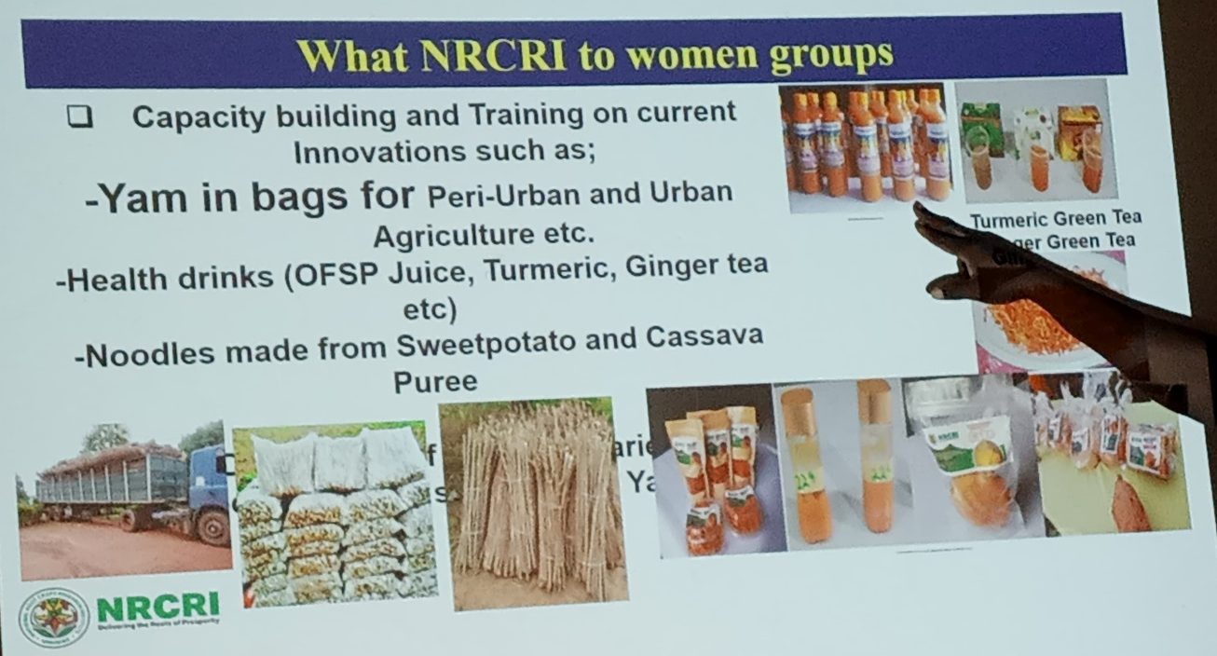

High quality Cassava Flour was used for making:
- Bread
- Chin-chin
- Meat/fish pies/rolls
- Strips, sausage rolls
- Queen cakes
- Biscuits
- Doughnuts
- Buns
- Fritters
- Croquettes and
- Salad cread
2.8 CHALLENGES INCLUDES
- Sustaining steady and stable yield levels
- Enhancing nutritional quality in vitamins and protein content for the malnourished poor.
- Creating an export market-driven root and tuber crops industry
- Transforming root and tuber into major players for economic developent and wealth creation.
- Development of new value-added products
- Increase funding of agricultural research and crop production for sustainable agriculture rebirth.
NRCRI stated that they are ready to impart knowledge to Smallholders Women Farmers in Abia State if the resources to facilitate training and knowledge transfer is available.
CSJ promised to share available information about research grants with NRCRI and extended a hand of fellowship to the Institute for further collaborations, especially in participatory research involving participatory agenda setting and dissemination of research results.
2.9 PHOTO SPEAK

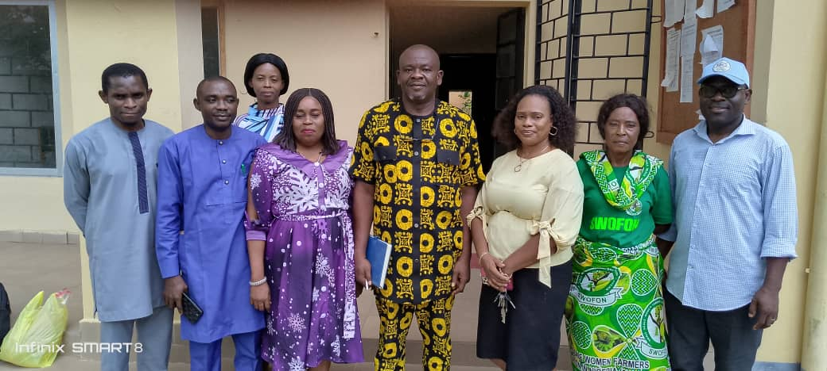

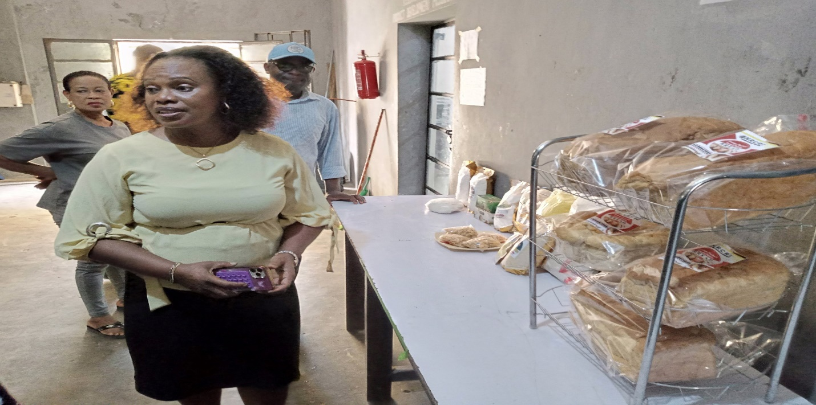
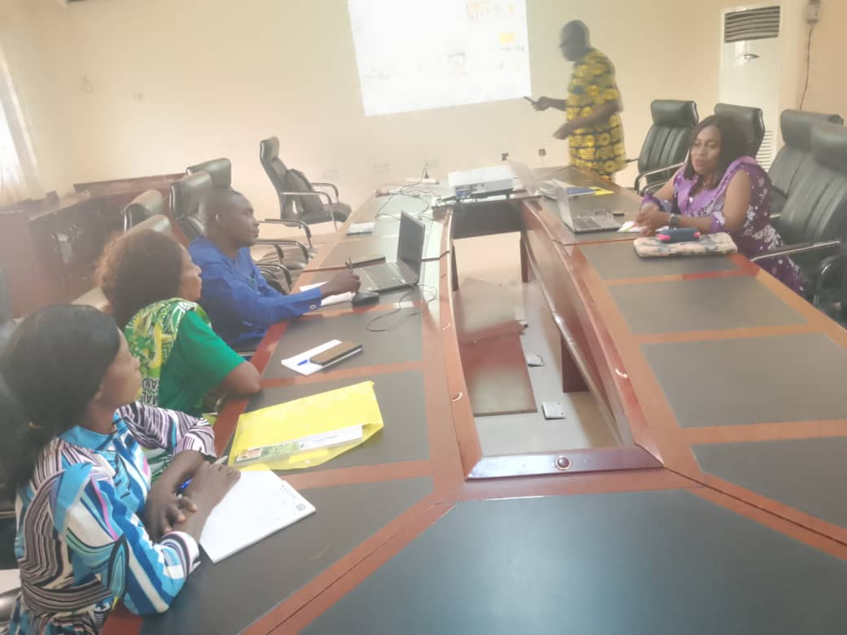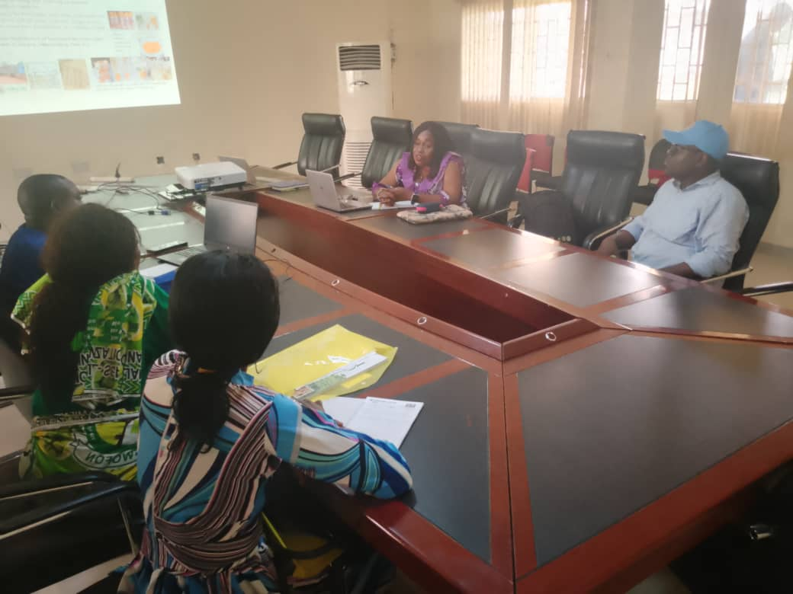

MINNA, NIGER STATE

3. REPORT ON KNOWLEDGE CO-CREATION: ENGAGEMENTS AND JOINT MEETINGS WITH RESEARCH INSTITUTIONS AND SWOFON IN NIGER STATE
3.1 INTRODUCTION
This report presents a summary of engagements and joint meeting conducted between Centre for Social Justice (CSJ) with the support of Henrich Boll Stiftung (HBS), Nigeria, National Cereal Research Institute (NCRI), Badeggi Niger State and the Smallholder Women Farmers Organization in Nigeria (SWOFON) in Niger State. The initiative has the objective of fostering knowledge co-creation through Focus Group Discussions (FGD) and interviews to document practices, challenges, knowledge gaps and existing solutions as well as promote gender-responsive agricultural research, and enhance smallholder women farmers’ participation in innovation processes.
A two-member team from CSJ, comprising Mr. Jekeli Samuel and Mr. Emmanuel Ngenegbo, was delegated to carry out the engagement in Niger State. The team traveled by road in a vehicle with registration number ABC-759NF, driven by Mr. Nelson Achema.
The team arrived at Doko Hotel on Sunday, 27th May 2025, and checked into their respective rooms, which had been pre-booked by the HBS team.
First Day Engagement (28th May, 2025)
3.2 STAKEHOLDER ENGAGEMENT SUMMARY
The engagement session had a total of 24 participants, including 20 members of the Smallholder Women Farmers Organization in Nigeria (SWOFON), 2 representatives from the NCRI, Badeggi, and 2 representatives from the CSJ.
3.2.1 Objectives of the Engagement
- To ensure that SWOFON members have a voice in setting the agricultural research agenda.
- To foster collaboration between NCRI, Badeggi, and SWOFON’s Niger State Chapter, thereby promoting demand-driven agricultural research.
- To increase the adoption of research-based agricultural practices among SWOFON members.
- To strengthen institutional frameworks to make agricultural research and extension services more inclusive and responsive to the needs of smallholder women farmers.
3.2.2 Summary of Activities
- A FGD and participatory workshop was convened at Doko International Hotel, Minna, Niger State, bringing together 20 SWOFON as against the originally planned 18 SWOFON representatives drawn from various Local Government Areas across the state and 2 key representatives from the NNCRI, Badeggi. The engagement served as a vital platform for interactive dialogue, enabling the women farmers to articulate their lived experiences, indigenous knowledge, and pressing agricultural challenges. NCRI researchers, in turn, shared insights from ongoing research and explored how these could be adapted to meet the specific needs of smallholder women farmers. The session fostered mutual learning, joint problem identification, and the co-creation of priority research areas, laying the groundwork for sustained collaboration between SWOFON and the research community in Niger State. Presentation of SWOFON's priorities include access to improved seeds, climate-resilient practices, and post-harvest technologies.
- In accordance with research ethics standards, a consent form was distributed to the participants to endorse, indicating that they have voluntarily given approval to participation in the FGD, for the host to take video recordings, voice recordings, pictures and statements that may be used in a publication.

- During the session, SWOFON members shared insights on indigenous farming practices and the challenges they face. To support this discussion, 20 tailored questionnaires were administered to the participating women farmers. Out of the 20 distributed questionnaires, 15 were properly completed, while 5 were returned blank. The unfilled questionnaires were primarily due to language barriers, as some participants were unable to read, write, or understand basic English. The questionnaire consisted of 19 questions, grouped into three key sections:
3.3 KEY DISCUSSION TOPICS, CHALLENGES FACED BY WOMEN FARMERS AND RECOMMENDATIONS FOR IMPROVEMENT
The table below presents a summary of the questions asked and the responses received from the participating SWOFON members.

S/No | Question Summary | Response Type | Respondents | Remarks
1 | Major crops farmed | Open-ended | 15 | The women farmers identified a diverse range of crops cultivated, including soybeans, rice, sesame seed, beans, vegetables, groundnut, guinea corn, maize, cassava, and yam. In addition to crop farming, several participants also engage in animal husbandry, specifically goat rearing and poultry farming.
2 | Cropping method used | Open-ended | 15 | Intercropping emerged as the most commonly practiced method among the respondents, while a few indicated the use of single-cropping system.
3 | Size of farmland | Quantitative | 15 | Farm sizes reported by respondents ranged from one plot to five hectares. The majority indicated owning approximately two hectares, while a few mentioned having as little as one plot, and others reported farm sizes up to five hectares.
4 | Soil preparation method | Open-ended | 15 | Manual clearing, burning, and tilling were the predominant soil preparation methods reported by the respondents. Some participants also mentioned zero tillage method where they sprayed chemicals on the farmland to kill stubborn weeds and organisms that may attack the crops and commence planting. This method was affirmed by others as being very effective too.
5 | Source of seedlings and inputs | Open-ended | 15 | The majority of respondents indicated that they source their seeds from personal storage carried over from the previous planting season. A few reported purchasing seeds from local markets.
6 | Estimated crop yield | Quantitative | 15 | Yield estimates provided by respondents varied by crop and were expressed in different units such as kilograms, tons, and bags. Below is a summary of the reported yield ranges:  - Maize:  - 10 – 30 bags  - 1 – 1.5 tons  - 70 – 200 kg per acre  - Soybeans:  - 50 – 100 kg  - Rice:  - 20 – 25 bags  - 1 – 1.6 tons  - Groundnut:  - 13 – 20 bags  - 1.0 – 1.5 tons  - Beans:  - 1 – 1.5 bags per acre  - Guinea Corn:  - 15 bags (reported consistently by all respondents who farm guinea corn)  This variation in measurement units reflects the informal methods commonly used by the farmers in estimating yield.
7 | Soil fertility method | Open-ended | 15 | Both organic compost and chemical fertilizers were reported as commonly used methods for maintaining or improving soil fertility. However, majority of the participants indicated the use of organic compost/manure in measured quantity more than fertilizers. This is because the organic compost is less expensive and better for crop maturity than fertilizers.
8 | Pest management approach | Open-ended | 15 | Manual and chemical methods were reported. Application of pesticides is a widely used as an efficient approach to curb pests according to their reports.
9 | Pest strategy differences by crop | Open-ended | 15 | Respondents attested to the fact that methods vary by crop, crops that are prong to pest infestation may require prophylactic measures in order to prevent its spread while crops that are less likely to be affected by pests will be monitored and controlled as the pest attack the crops.
10 | Weed management strategy | Open-ended | 15 | Hoeing and the use of herbicides were identified as the common practice. Both practices are combined to achieve the best control over the weeds in the farm land according to their reports.
11 | Weed strategy differences by crop | Open-ended | 15 | Respondents attested to the fact that methods vary by crop type.
12 | Harvesting process | Open-ended | 15 | The respondents indicated that they predominantly use manual harvesting techniques, including hand-picking, the use of sickles, and occasionally rudimentary tools. Majority of the participants agreed to the use of manual labour with their basic farm tools. The topography of the farmland also discourages the use of machines and other innovations for harvesting; some of the farm lands are hilly and the local farmers cannot handle these machines in such area.
13 | Storage and preservation methods | Open-ended | 15 | Storage in air tight sacks was the response by all participants, especially for grains.
14 | Waste management approach | Open-ended | 15 | Respondents reported various waste management practices, including mixing farm wastes to produce manure, selling wastes to animal farmers, and recycling agricultural residues.
15 | Protection from climate/environmental threats | Open-ended | 15 | The majority of respondents indicated that their primary method of protecting against climate and environmental threats, such as prolonged drought, is delaying planting until weather conditions are more favorable.
16 | Processing steps for farm products | Open-ended | 15 | Processing methods varied by crop, according to respondents. Some reported taking rice to the mill for processing, while others noted they process their crops manually. For example, maize is processed into flour, pudding, and local delicacies; soya beans is used to produce soya milk and soya cake; and rice is also processed into rice cakes.
17 | Training received in last 3 years | Open-ended | 15 | Some respondents indicated that they had participated in various agricultural trainings over the past three years. These trainings were organized by institutions and programs such as AGRA, GIZ, NEWP, Feed the Nation – Food Security, and Feed the Future.
18 | Challenges across farming activities | Categorical & Open-ended | 15 | - Manual soil preparation and lack of mechanization increase labor costs.  - Access to quality seeds is limited, and input delays disrupt planting.  - Soil fertility is declining due to inadequate fertilizer use and continuous cultivation.  - Water supply depends on rainfall, with no irrigation support.  - Weed and pest control are labor-intensive, with some resistance issues.  - Harvesting is slow and manual, causing losses.  - Poor storage leads to postharvest losses, spoilage.  - Weak processing capacity limits value addition.  - Climate issues like drought and erosion coupled with poor roads and limited funding.  - Insecurity  - Weak extension services further hamper productivity.
19 | Recommendations to address challenges | Open-ended | 15 | - Provision of Gender-Friendly Equipment: Agricultural tools and machinery should be designed to accommodate the physical needs and capacities of women farmers.  - Improved Security: Strengthening security in farming communities to ensure safe access to farmlands and markets.  - Access to Grants: Provision of targeted financial support and grants to empower women farmers and support their agribusiness initiatives.  - Timely Availability of Fertilizers: Fertilizers should be made available early in the planting season to ensure they are utilized effectively, rather than arriving late when they are no longer needed.  - Access to Quality Seeds: Ensure the availability and affordability of high-quality seeds to enhance crop yields.  - Favorable Government Policies: Advocacy for policies that prioritize and support smallholder and women farmers in agricultural planning and implementation.  - Capacity Building and Training: Regular training programs for women farmers to build their knowledge and skills in modern farming techniques and agribusiness management.  - Market Linkages: Facilitate connections between women farmers and local, regional, and national markets to ensure they have access to fair pricing and consistent demand.  - Improved Rural Infrastructure: Development and maintenance of good road networks to ease transportation of farm inputs and produce.

3.4 CONCLUSION
Sessions were held focusing on critical aspects of agricultural production and resilience building. Discussions covered the entire farming cycle, beginning with land preparation, progressing through planting, crop management, harvesting, and concluding with post-harvest handling and storage practices. Participants explored traditional and modern farming methods, highlighting indigenous knowledge systems as well as innovations introduced through research and extension services. Key challenges encountered by SWOFON members in the course of food production were openly discussed, including limited access to mechanization, poor soil fertility, unpredictable weather patterns, pest and disease outbreaks, lack of inputs and post-harvest losses. Participants also shared resilience strategies they have adopted, such as collective labour systems, organic soil enhancement techniques, early planting strategies, and community-based storage solutions. Finally, the session concluded with practical recommendations aimed at strengthening resilience, including improved access to climate-smart inputs, targeted capacity building, stronger partnerships with research institutions, and better access to extension services tailored for women farmers.

4. CSJ TEAM VISIT TO THE NATIONAL CEREALS RESEARCH INSTITUTE (NCRI), BADEGGI, NIGER STATE ON THE 29TH MAY 2025

4.1 INTRODUCTION
A strategic visit was undertaken to the National Cereals Research Institute (NCRI or the Institute) in Badeggi, Bida, Niger state where the delegation was warmly received by the Acting Director General of the Institute. The visit was undertaken against the background of the issues identified in the FGD with SWOFON and NCRI the previous day. In his welcome address, the Acting DG provided a comprehensive overview of the institute’s core mandates, ongoing research activities, and innovations targeted at improving cereal and legume value chains in Nigeria.
4.2 CORE MANDATE OF NCRI
The institute has the national mandate to:
- Conduct agricultural research and development to improve productivity with specific focus on 6 mandate crops – Rice, Soybean, Sugarcane, Acha (fonio), Benniseed (sesame) and Castor.
- Breeder’s seeds production for distribution to farmers and other stakeholders.
- Developing agricultural technologies and mechanization for more efficient farming.
- Studying the social economies aspect of farming to improve farmers livelihood and Agric extension services.
- Overall farming system research for the North Central Agriculture Zone (Niger, Nasarawa, Kwara, Federal Capital Territory, Benue, Plateau and Kogi States)
The Institute has 10 outstations located in Ibadan, Amakama, Birnin-Kebbi, Mokwa, Uyo, Yandev, Bacita, Numan, Warri And Riyom where they carry out ecology specific studies on crops on its mandate.
The team was formally handed over to a group of technical experts and senior researchers who conducted a guided tour of key departments and research facilities. During the tour, the team actively engaged with, listening to their concerns and identifying practical entry points for collaboration to address SWOFON’s challenges such as access to improved seedlings, training opportunities, post-harvest management, and gender-responsive extension services.
4.3 AREA OF WORK:
- Research operations – with focus on seed research and genetic improvement.
- Food technology and value addition – innovation, preservation, processing and enhancing the mandate crops for economic and utility value.

- Extension operations – outreach and commercialization of research result.

- Mechanization and technology development – creation of machineries for simplified farming and increased productivity.

- Collaborations – works with national and international institutions and relevant organizations to enhance research impact.

4.4 ACHIEVEMENTS
- Improved and High-Yielding Seeds and Crops: Production of improved and high yielding, draught resistant varieties of rice, sugar cane, soybeans, beniseed, acha and castor. The institute has developed over 70 varieties of rice (FARO 44, TEGGOLD, 6444GOLD etc.), and many varieties of other mandate crops and these varieties has shown potential in multiplying yields per hectare.

- Development of Gender Friendly Machineries: Different gender friendly pre and post-harvest agricultural machineries and equipment like planters and rice processing machines. These machines have proven to be user friendly and efficient for the women farmers.

- Value Addition and Processing: The Institute developed improved processing method for their mandate crops. Women have been thought how to produce different kinds of snacks and products from rice, soybeans and other crops.

- Improved Soil and Pest Management: The Institute continues to conduct research from the data collated from farmers on how to manage pest and improve soil activities. NCRI, from time to time, has developed and shared pamphlets or small booklets to the local farmers on how to manage and improve their farming activities.

- Agriculture Extension Services: Through the Agriculture Extension Department, the Institute disseminates their research findings through training and extension services. The Women in Agricultural Unit is a key part of the extension program of the institute.

- Establishment of the Research Extension Farmer Input Linkage System (REFILS) program. This program presents a platform for researchers and local farmers to link up and incorporate farmers into the research work of the Institute.
4.5 COLLABORATION WITH WOMEN FARMERS
- The Institute revealed that they have been actively working with local farmers through training and capacity building workshops where women are taught skills and techniques on post-harvest processing and preservation of rice.

- The Women in Agriculture (WOA) Unit in the Extension Department of the Institute with a special focus on local women farmers goes to the field to identify current challenges and addresses gender specific constraints in crop production, outputs and mechanization.

- Through the programs conducted by the Institute, women are empowered with value addition skills in processing and producing variety of products from the mandate crops like rice snacks and sweeteners.

- The Institute, from time to time, depending on the availability of funds distributes new varieties of seeds to the women farmers to empower them and initiate the production of that variety.

- The Institute also conducts gender specific research tailored to identify more gender dynamics in agricultural processing, which will help inform its works with women farmers.

- The role of the socio-economic team of the Institute was also emphasized. The team conducts profitability and risk assessments of the Institutes innovations which will ensure that any machine or tool developed and rolled out by the Institute offers potential economic benefits to the users. For women in particular, this assessment helps them determine whether to adopt certain technologies based on their financial and practical value.

4.6 CHALLENGES
Despite its impact, the Institute has suffered repeated challenges in delivery of their mandate.
- Inadequate Funding: The Institute is poorly funded to achieve their desired mandate. They highlighted that funds disbursed to the Institute is merely enough for recurrent expenditure. With adequate funding, the technology developed by the Institute will have a wide reach. NCRI can undertake demonstrations and trials with the local farmers as this method is important for the farmers to understand the concepts NCRI has developed. This is a reference to participatory farming process in technology adoption.

- Issues of Insecurity, Terrorism and Banditry: These challenges ravaging the region makes it increasingly difficult for the Institute to conduct routine outreach, as participants may be unwilling to further engage because of the activities of herds men on their farmland or in some instances, extension services launched could not be sustained as the villagers are unwilling to risk their lives in distant farms due to the insecurity.

- Climate and Environmental Factors like flooding and draught is a major setback to the implementation of the Institute’s work and sustainable agricultural development. These climate related challenges, which is compounded by limited control over natural events, continue to threaten and delay the progress made.

- Another rising problem is access to land, these women farmers who are beneficiaries of part of their husband lands are largely losing these privileges as the husbands have barely enough lands for their own farming activities. Even where there are available lands, the cost of cultivation especially for women farmers who may need a lot of support and hired labor defeats the profitability of the whole farming activities.
However, despite these challenges, NCRI recognizes how the rise of social media has helped the Institute to reach a wider audience and extend their reach. Furthermore, cultural barriers which prevent women from engaging in training and technology adoption have been reduced due to the facilitation of their Extension Team.
The Institute acknowledged the vital role of local women farmers in agriculture and expressed gratitude for the opportunity provided by this program particularly the chance to engage with SWOFON and establish a direct channel for engagements, sharing information and delivering value to them.
4.7 KEY OUTCOMES OF THE VISIT
Priority Research Areas Identified:
  - Drought-tolerant and early-maturing seed varieties.
  - Organic and low-cost chemical fertilizer alternatives.
  - Post-harvest storage innovations tailored to women farmers.
- The meeting presented an opportunity for NCRI’s recommitment to inclusive research and technology development, especially for smallholder women farmers.
- NCRI has granted SWOFON direct access by providing them the hotlines to reach the Institute.
- NCRI also committed to make available new and improved seeds to SWOFON.
- There is an agreement on regular feedback mechanisms to integrate farmers’ input into ongoing research.
- NCRI is also open for collaborations with governments, non-governmental and international organizations and all relevant stakeholders
4.8 CONCLUSION
The engagements between SWOFON and NCRI have laid a strong foundation for participatory agricultural research. The initiative has proven that joint knowledge creation not only enhances the relevance of research but also empowers women farmers to contribute meaningfully to innovation systems. Sustained collaboration will be key to achieving transformative outcomes in agriculture.
4.9 PHOTOS WITH NCRI STAFF
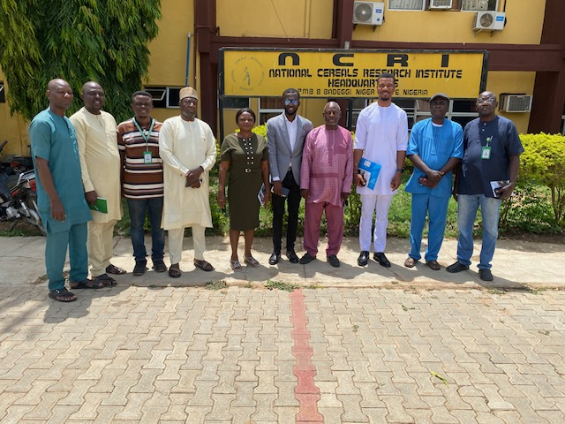
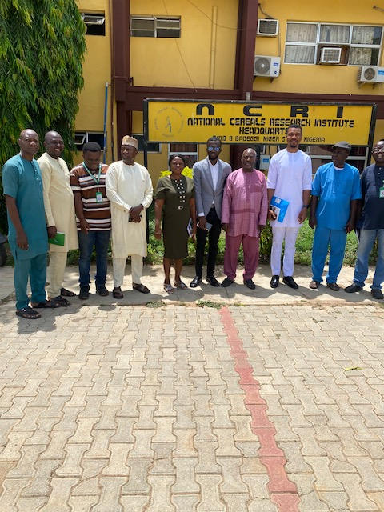

IBADAN, OYO STATE

5. KNOWLEDGE CO-CREATION AND STAKEHOLDER ENGAGEMENT FOR NEEDS ASSESSMENT OF SMALL-SCALE WOMEN FARMERS ORGANIZATION IN NIGERIA (SWOFON) THROUGH A FOCUS GROUP DISCUSSION (FGD) ON 26TH MAY, 2025
5.1 INTRODUCTION
The meeting held between 9:30am to 2:50pm at Justice Development and Peace Commission (JDPC), St Patrick Catholic Church Basorun Road Ibadan.
Attendees
Name Organization/Role
- Ajao Elizabeth SWOFON Member
- Rasheed Nasirat SWOFON Member
- Bola Otularu SWOFON Member
- Adeniran Olubuisi SWOFON Member
- Lanase Rukayat SWOFON Member
- Oyelakin Bola SWOFON Member
- Romoke Jinadu SWOFON Member
- Mogboni Ubola Sekinat SWOFON Member
- Yunus Jemilat SWOFON Member
- Olawuwo Kehinde .E SWOFON Member
- Ojelele Olayinka SWOFON Member
- Oyedeji Oluwatoyin SWOFON Secretary
- Akinbade Roseline A. SWOFON Coordinator
- Oyeniran S.O SWOFON Treasurer
- Irekeolza A. SWOFON Financial Secretary
- Oyetunji Oluremi Olufumilayo SWOFON P.R.O
- Dr. Oyedokun M.O Senior Research Fellow (SRF) IART
- Dr. Amusat Adeniyi PRF IART
- Dr. Anthony Oyedeji SWOFON Consultant
- Nnorom Prince Finance Officer, CSJ
- Eze Onyekpere Lead Director, CSJ
5.2 OPENING SESSION
The Focus Group Discussion (FGD) commenced at 9:30am with an opening prayer said by the Public Relations Officer of SWOFON Oyo State, Mrs. Yetunji Oluremi followed by an opening remark from Eze Onyekpere.

The Lead Director of CSJ, Eze Onyekpere, extended greetings to all attendees. He expressed his profound gratitude and welcomed all participants to the discussion. Going further, he gave an overview of the background of the program. He said that Nigeria, at the federal level, has sixteen publicly funded agricultural research institutes and their activities are centered on certain aspects of agriculture including crop production, livestock management, fishery, horticulture, forestry, etc. He said that these research institutes have developed a lot of innovations over the years. He raised the poser; ‘how have the works of these research institutions improved farming practice, yield, reduced drudgery and generally improved the livelihoods of local grassroot farmers, especially small-scale women farmers?’
There are available innovations from Nigerian research institutes on land clearing and soil preparation, improved seeds, stems and seedlings, planting, weeding, pest control, organic fertilization of lands, reduction of post-harvest losses, value addition and processing as well as general automation and mechanization of farming processes. If research innovations have left the shelves of research institutes and practically moved into the field through extension services, the productivity, value addition and economic spinoffs of the sector would have doubled thereby creating more jobs, improving earning capacity as well as enhancing public revenue from the sector. He emphasized the importance of collaborative efforts in addressing the challenges faced by small scale women farmers in Nigeria under the umbrella of Small-Scale Women Farmers Organisation of Nigeria (SWOFON).
It is against the background of the foregoing that CSJ is collaborating with Heinrich Boll Stiftung on mapping of research institutes, needs assessment of SWOFON, convening critical stakeholders to chart pathways of informing and improving policy decisions and policy implementation and to ensure that interventions are tailored to the specific requirements of these farmers. The objectives of this intervention are:
- Ensure SWOFON members have a voice in setting the agricultural research agenda.
- Foster collaboration between research institutions and SWOFON to make agricultural research more demand-driven.
- Identify and address challenges faced by research institutions in translating their work into practical solutions for women farmers.
- Increase the adoption of research-backed farming solutions by women farmers.
- Strengthen institutional frameworks to make research and extension services more inclusive and responsive to women farmers.
- Advocate for policy and political commitments to ensure agricultural research institutions are demand-driven.
He concluded by stating that the purpose of the gathering was to assess the needs of small-scale women farmers through a Focus Group Discussion (FGD) in order to ascertain the challenges faced by these farmers on a day-to-day basis in their farming activities ranging from land clearing, cultivation, weeding, harvesting, storage, value addition and processing, etc. He encouraged the women farmers to participate actively and discuss the issues and questions to be raised during the sessions.
Dr Amusat Adeniyi from the Institute of Agricultural Research and Training (IART) also welcomed the participants. He stated that the gathering was very important because it will foster collaboration between women farmers and agricultural research institutions. Over the years, the research institutes provided innovative solutions to farming challenges but there has always been the missing link of ensuring that these innovations are available to farmers in real life.
However, he indicated the official link between research institutions and farmers known as Research-Extension-Farmer-Input Linkage System (REFILS), - a framework in Nigeria aimed at strengthening agricultural development by connecting research, extension services, farmers and input suppliers. It serves as an umbrella organization coordinating activities for Agricultural Development Programmes (ADPs). Furthermore, Dr Amusat stated that REFILS plays a crucial role in improving the productivity, sustainability and profitability of farming, especially for small scale farmers. He said that the system strengthens capacity building and improves livelihoods. He encouraged SWOFON to contribute meaningfully to the program.
5.3 INTRODUCTION AND RESEARCH ETHICS
Attendees introduced themselves, sharing their names, organization and roles. Thereafter, in accordance with research ethics standards, a consent form was distributed to the participants to endorse, indicating that they have voluntarily given approval to participation in the FGD, for the host to take video recordings, voice recordings, pictures and statements that may be used in a publication. Eze Onyekpere introduced the FGD and its methodology including the need for everyone to participate freely, express ideas openly, objectively and without fear or favour. No one will be victimized for airing his opinion.
5.4 KNOWLEDGE CO-CREATION AND STAKEHOLDER ENGAGEMENT: FOCUS GROUP DISCUSSION.
5.4.1 What are the major crops that you farm?
The women farmers gave various responses to this question. Ajao Elizabeth responded that she plants cassava, maize and soya bean. Romoke Jinadu said she plants cassava, maize and vegetables - spinach to be precise. Rasheed Nisirat said she plants maize, cassava and tomato. Bola Otularo replied that she plants maize. Oyelakin Bola said she plants cocoa and cashew. Lanase Rukayat said she plants maize, cassava and cocoa. She is into poultry as well. Olawuyo Kehinde Esther replied that she plants cassava, tomato, maize and rears goat. Mogboni Ubola Sekinat reported that she plants maize, yam, cassava, egusi melon. Oyedeji Oluwatoyin said she plants cassava and maize and that she is into poultry too while the coordinator, Akinbade Roseline said that she has a poultry and fish ponds. She also plants cassava and yam.
Essentially, the annual crops identified include cassava, maize, yam, soya bean, plantain, and vegetables including tomato, spinach, egusi melon, green vegetables, pepper and okro. Sugar cane is also planted. The tree crops are cashew and cocoa while poultry, goat rearing and fishery is also practiced by the women. However, maize and cassava are the most commonly grown crops.
    - Briefly describe the method of cropping you adopt in your farm?
The women attended to this question giving their various response. The major practices were:
- Single or monocropping including growing one crop on a piece of land for an entire farming season or sequential cropping being the practice of growing two crops on the same piece of land, planting and harvesting one before planting and harvesting the other.

- Multiple cropping includes intercropping which involves growing two or more crops on the same piece of land at the same time. Mixed cropping- two or more crops are grown simultaneously on the same piece of land. This is the most common method used by the women farmers.

- Crop rotation being the farming practice where different crops are grown in a specific sequence on the same land over a period of time.

- Farmers knowledge of sack farming for tubers and vegetables which requires less land area as the cropping is not into the soil, was very limited.

    - What is the size of your farmland?
When asked about the size of their farmland, Elizabeth Ajao stated that she owns three and a half acres of land where she farms. Bola mentioned having half an acre similar with Rukayat. Oleleye Olayinka said she owns one plot. Bashiri replied that she owns seven acres. Oyetunji replied saying that she owns two acres. Several other women also shared the sizes of their farmland. The responses from the women indicates a wide range variation in the sizes of farmland they own, ranging from as small as one plot to as large as seven acres and five hectares.
5.4.4 Briefly describe your method or approach to soil preparation before planting?
The women explained that they begin with land clearing, followed by gathering grasses and debris which they would then pack at the edge of the farmland. They do not burn the bush to clear the land. They collectively stated that the land clearing is done manually. However, the state has a tractor hiring service which is overstretched because commercial farmers are also eligible to apply for the use of the tractors which most of the times keeps the tractors busy during the soil preparation season.
5.4.5 How do you source your seedlings and other farm inputs at the start of each farming season?
The women generally responded that they purchase seeds from the open market. They also said that the government provides them with seeds occasionally. However, they were advised and recommended to source their seeds from research institutions such as IART, NIHORT and other agricultural research institutes. IART representatives gave information on the seeds, stems and other planting materials available at their institute.
5.4.6 What is the estimated yield of your crops? (measured in kg, or tons per crop or per hectare)
In response to this, the SWOFON women collectively replied that they typically harvest about 100 - 150 kilograms of maize per acre. However, they complained that the crop’s (maize) yield last year was poor due to early cessation of rainfall. Yam yields are approximately 240 tubers per acre. The women generally reported harvesting about four bags (50kg rice sack) of cassava from one plot of land and about 2000 kilograms of tomato per acre.
5.4.7 What is your approach to maintaining or improving the fertility of your farmland for improved yield? (fertilizers, compost, farming practices, etc.)
The women replied that they use a combination of methods which include NPK fertilizer, poultry waste, animal waste and compost manure. However, artificial chemical fertilisers are very expensive and generally not affordable by women farmers. There is limited knowledge of using crop rotation to maintain soil fertility.
    - How do you manage pests in your farmland?
The response is that they primarily use chemical pesticides. These pesticides are costly. The farmers have a limited knowledge of the toxic and hazardous nature of these pesticides and the damage they inflict on biodiversity and the environment. The farmers do not use personal protective equipment while using these chemicals. Very few of them have adopted the use of biological controls, biopesticides. The major natural materials so far used by the few are from Moringa and Neem trees. But several natural and ecologically friendly pest control products, services and farm management techniques have been developed by IART and NIHORT in Ibadan. The two research institutes have also developed seed and crop varieties that resist pest or manage them better. The farmers seem to be unaware of these developments.
    - What method or strategy do you adopt for weed management during the farming season?
They replied that they make use of manual labour and a few use chemicals to control weeds. However, the chemicals are costly. But they have little knowledge of biological and cultural weed control.
5.4.10 Briefly describe the process of harvesting the crops that you produce from your farm?
Collectively, they responded that they harvest their crops manually using simple tools such as hoe and cutlass. They said that although this method is labour intensive, it is what they can afford.
5.4.11 Briefly describe your method or approach to managing storage and preservation of your farm produce after harvest?
The reply was based on examples of crops they cultivate. For maize, they store it in drums after reducing the moisture content with the use of moringa leaves with which they dry the maize. Yams are stored in barns where they can last for over six months before the next planting season. Cassava is usually processed immediately after harvest. Little or no preservation is done for tomatoes, although it can be sun dried. Pepper can be dried and grinded and preserved for some months. Most green vegetable are sold and used immediately after harvesting.
    - Briefly describe how you manage wastes from your farmland?
After land clearing and harvest of crops, the leaves are left to decay as manure. For animal wastes, they are sold to generate income.
5.4.13 How do you protect your farms from severe climate and other environmental conditions like erosion, prolonged dry period (draught), etc?
They responded that they create contour ridges to control erosion; they also apply mulching using plant residues from high residue crops. But cover cropping is not a popular idea considering the labour implications.
5.4.14 Have you received any form of training on farming, farm management, or any aspect of the agricultural value chain in the last three years? If yes, kindly give details.
The SWOFON women responded affirmatively. They said that their coordinator usually sends them to various seminars and they give reports when they return. These training encompass the value chain of crops and animals. However, IAR&T indicated that they broadcast knowledge and innovation through radio in local language across five states of the South West geopolitical zone vis, Ekiti, Ogun, Ondo, Osun and Oyo states.
5.4.15 Steps in agriculture processing and value addition after harvest
Majority of the farmers simply harvest and sell; and add little or no value to the crops. However, cassava is processed into garri while fish is dried and sold at a later date.
5.5 CHALLENGES
Identify the primary challenges that you encounter in your farming practices?
5.5.1 Soil Preparation: In the area of soil preparation, the women rely entirely on manual land clearing which is time consuming and labor-intensive. In a bid to mitigate the labour and stress, they hire laborers on certain occasions. However, they laid complaints that the laborers who they hire fail to deliver on the job after collecting money from them.
5.5.2 Access to Good and Quality Seeds: It was observed from the discussion that women have limited access to good and quality seeds. This is one major challenge they encounter during planting.
5.5.3 Soil Testing: The women use a mixture of chemical fertilizers and organic manure but often without soil testing. This poses a threat to their crops. They fail to practice soil testing which would help them to ascertain the fertility and health of the soil before planting. A soil test will reveal lacking nutrients and other challenges to facilitate proper remedial soil fertilization.
5.5.4 Drudgery in Farming: They lack modern mechanized tools for farming. Planting, weeding, harvesting, etc., is usually done manually by the women.
5.5.5 Modern Agricultural Practices: The women are not exposed to modern agricultural practices. They lack facilities for preservation of perishable crops like vegetables and tomatoes. Although traditional storage methods are practiced (yams are stored in barns, maize in drums, etc.), modern preservation and cold chain storage is not available.
5.5.6 Rainfed Agriculture: Oyo State has several dams vis Ikere Gorge Dam, Asejire Dam, Eleyele Dam; smaller dams and water schemes all over the state, including Oyo, Iseyin (Koso and Atori), Ogbomoso, Eruwa, Igboho, Kisi, Igbeti, Ago-Amodu, Iganna, and Ajinapa. But these dams have not been activated and reticulated for irrigation to promote all year-round farming.
5.5.7 Climate Change and Environmental Challenges: For instance, late rains and cessation of rain was observed. They complained that this affected the yield of their maize for the previous year as compared to what it yields in the years before.
5.5.8 Limited Training and Extension Support: There is so much innovation, knowledge and information available at research institutes like IAR&T and NIHORT compared to what the women know and practice. Research knowledge is not being maximized due to the absence of critical extension services.
5.5.9 Access to Information: This is a critical challenge in terms of not getting informed of available credit, subsidies, insurance, etc., opportunities available from governments and other stakeholders. For instance, a good number of the farmers did not benefit from the trillion naira Anchor Borrowers Programme of the Central Bank of Nigeria.
5.5.10 General Insecurity: Herder farmer challenges, kidnapping and other security issues plague day to day farming and threatens the lives and livelihood of farmers.
5.6 RECOMMENDATIONS
- Oyo State Government to expand and improve their Tractor Hiring Service and make same available to small scale women farmers. It is recommended that at least 35% of the tractors should be put at their service. Commercial farmers should not be prioritised in the service over small scale women farmers.

- Oyo State Government to invest more in extension services through the State Agriculture Development Programme (ADP) in collaboration with local governments who have been granted financial autonomy through the recent Supreme Court judgement.

- SWOFON members are encouraged to take advantage of the knowledge resources available at IAR&T and NIHORT. For instance, they should source their seeds from agricultural research institutes like NIHORT and IART as they have innovative seeds and stems for improved yield, pest and disease resistant and climate change resilient.

- Gender friendly machines and low-cost technologies which the women can afford which have already been developed by research institutes (like the National Centre for Agricultural Mechanization Ilorin and National Cereals Research Institute, Badeggi, Niger State) should be commercialized to ease the burden of manual agricultural practice by the women. State and local governments should appropriate resources in the budget to makes these machines and equipment widely available.

- CSJ and SWOFON secretariat in collaboration with other stakeholders to set up a Farming Information Centre to disseminate relevant information and opportunities of interest to small scale women farmers.

- SWOFON should take advantage of the radio programmes from IART so as to gain valuable information that are essential for their farm practices.
5.7 CLOSING
At the close of the meeting, the Public Relations Officer of SWOFON, Mrs. Oyetunji Oluremi appealed to the two representatives from Institute of Agricultural Research and Training (IART), Dr. Oyedokun and DR. Amusat urging them to take the concerns and challenges shared by the women farmers back to the institute for further action. She expressed appreciation for the commitment shown by the Lead Director of Centre for Social Justice, Eze Onyekpere, especially for his continued interest in addressing the needs of SWOFON. In response, Eze Onyekpere extended his gratitude to all the participants for their active engagement and meaningful contributions during the focus group discussion. The meeting came to an end at 2:50pm with a closing prayer said by Mrs. Rasheedat.

6. VISIT TO THE INSTITUTE OF AGRICULTURAL RESEARCH AND TRAINING (IAR&T), APATA, IBADAN, OYO STATE ON 27TH MAY, 2025 BY THE CENTRE FOR SOCIAL JUSTICE TEAM.
6.1 ATTENDANCE
The meeting commenced at exact 10:30am with registration of participants. In attendance were three representatives from SWOFON, Oyo State Chapter, The Coordinator- Akinbade Roseline, Secretary - Oyedeji Oluwatoyin, PRO – Olutunji Oluremi Olufumilayo. Representatives from the Institute, Dr Udemba Ibukumolu- Research Fellow; Idowu Tolulope Charles- Research Fellow; Dr Amusat Adeniyi- PRF; Prof. J.A Adetumbi – Deputy Director IAR&T; Dr Oyedokun M.O - Senior Research Fellow; Professor Dauda T.O – Professor; Dr Uthman A.C.O- RFI; Dr. Omotoso S.O – RFI; Nnorom Prince – Finance Officer, Centre for Social Justice (CSJ); Eze Onyekpere – Lead Director CSJ.
6.2 OPENING REMARKS
The Deputy Director of IAR&T gave a brief history of the Institute. He said that the Institute was established in the year 1969. The mandate is extensive and diverse in areas such as crops and livestock. The research work of the institute is demand-driven and practicable. IAR&T has seven stations across the South West geopolitical zone of Nigeria. He welcomed the CSJ team, representatives from SWOFON Oyo and staff of the Institute present.
Attendees introduced themselves, sharing their names, organization and roles.
6.3 DISCUSSIONS
Eze Onyekpere gave an overview of the project intervention. The project’s objectives include a discovery of the extent to which the innovations and findings of agricultural research institutes have impacted on the farming and full value chain activities of small-scale women farmers. He asked to know what practically and actually have been done by IAR&T in relation to its mandate on the value chain of crops from soil preparation, planting, weeding, fertilizing, harvesting, processing, etc.
He stated that if research institutes have been collaborating with women farmers, there will be a significant level of improvement in crop yield, value added and improvement in livelihoods. Eze Onyekpere highlighted the activities and expected outcomes of the intervention:
- To improve the productivity of SWOFON in Oyo State.
- To assess the innovations and findings of research institutes and their impacts on SWOFON.
- To document the work of research institutes and their impact on the agricultural and farming practices of SWOFON.
- To assess the needs of SWOFON
- To ensure that relevant research findings are disseminated through extension services.
The Soil Scientist and Livestock expert, Professor Dauda T.O said that the research of IAR&T is demand-driven, based on the needs of farmers and the mandate of the Institute. The Institute works with the REFILS (Research Extension Farmers Input Linkage System) which connects researchers, farmers, input sellers and extension personnel. REFILS is bi-directional. The Institute is easily assessable to farmers.
Dr. Usman spoke on the IAR&T’s innovations on composting, fertilizers and soil testing. The Institute has done a lot of work and generated innovations on composting, biofertilizers and biopesticides. IAR&T enlightens farmers about materials to use for organic fertilisers. The Institute has packaged compost materials which serve as fertilizers. IAR&T produces biochar which is used in soil amendment to improve soil health, increase carbon sequestration and potentially mitigate climate change. It activates the phosphorus in the soil. The Institute trains farmers on how to make use of biochar which is a versatile material used to check the activities of nematodes and limit their effect on plants. IAR&T has expertise in soil testing and encourages farmers to practice soil testing because it helps to ascertain the type of crops that can be grown in a farmland. This will help to explain the structure, nature, nutrient levels and how the environmental condition can be managed so as to prevent weeds.
Dr. Omotosho Sunday, who is the Animal Scientist and Expert in ruminants production spoke on the innovation of the institute in the aspect of animal cross breeding. He said that the Institute has been able to crossbreed the West African Black Goat with Sokoto Red Goat so as to get a more resilient breed that will produce more meat, adjust to environment and weather conditions and survive in the southern part of Nigeria. The Institute is currently crossbreeding the Muturu- the West African native cattle, and Ndama cattle breed so as to improve on the size and have a crossbred of the two. The Institute seeks to repopulate the Muturu breed in all South Western part of Nigeria. Also, IAR&T have been working on how to improve the quality of feeds given to animals. The feeds devised in IAR&T are fortified with nutrients to ensure that these livestock do not have a stunted growth. The Institute has worked on grasses sufficient enough to feed these animals - with a protein content of about 15%.
Eze Onyekpere sought to know whether IAR&T collaborates with the National Animal Production Research Institute (NAPRI). Dr Omotosho responded that they collaborate.
Furthermore, the animal scientist explained that the Institute has also made innovations in poultry. The Institute has been able to crossbreed the Fulani eco type chicken and with IAR&T’s own exotic product and they have a good result. They have also conducted research in the Eastern and Norther parts of Nigeria in order to figure out how these chickens can adapt in different ecological zones.
Dr. Oyedokun highlighted a concern raised during the FGD held the previous day. A female participant had expressed frustration over birds frequently destroying her crops, which led her to resort to the use of chemicals as a preventive measure. In response, Dr. Udemba advised against the use of chemical solutions due to their potential harmful effects on both the environment and human health. Instead, she recommended safer and more sustainable alternatives such as using reflective materials like old CD tapes, which effectively scare birds away. Additionally, she mentioned that mechanical deterrents could also be employed as a non-chemical approach to crop protection.
Dr. Usman contributed to the discussion by speaking on the nutritional and medicinal value of Moringa in animal husbandry. He stated that Moringa leaves can be incorporated into poultry feed, serving not only as a nutritional supplement but also as a natural remedy against common diseases in chickens. He emphasized that Moringa is more beneficial compared to synthetic antibiotics, offering a more organic and health-conscious alternative for poultry farmers.
Following this, Mrs. Oyetunji Oluremi, a representative of SWOFON (Small-Scale Women Farmers Organization of Nigeria), asked for clarification on how Neem and Moringa are applied in poultry farming. Dr. Omotoso responded that these medicinal plants are usually mixed with regular livestock feed, ensuring easy consumption by the animals while delivering health benefits.
Dr. Udemba further elaborated on pest control innovations from the Institute. She informed participants that the Institute has developed a biological solution involving army worms that are effective in controlling pest infestations in crops. These biological agents are available for purchase at the IAR&T seed store at a relatively cheap cost.
Eze Onyekpere raised a critical observation regarding the lack of awareness and collaboration between SWOFON and IAR&T. Despite the significant agricultural work being carried out by the Institute, it appeared that many SWOFON members were not familiar with IAR&T's activities and innovations.
Prof. Dauda responded saying that IAR&T disseminates information to farmers through radio programs broadcasted on five different stations. He acknowledged knowing several farmers’ groups but admitted that he was learning about SWOFON for the first time during this meeting.
Dr. Amusat said that it was unlikely that SWOFON members were unaware of IAR&T, given the Institute’s extensive reach across all the states of the South West geopolitical zone. He emphasized that almost every farmer group in the region has benefited from IAR&T's research innovations. Dr. Amusat also spoke on the strong linkages between federal, state, and local governments in agricultural extension services, highlighting that the Institute plays a key role in these collaborative efforts. He encouraged women farmers to regularly listen to IAR&T’s radio programs, as they offer valuable agricultural insights and good agricultural practices that can improve farm productivity.
6.4 FINDINGS AND RECOMMENDATION
The interaction brought to the fore the tremendous work done by the research institute. However, SWOFON women were unaware of these works, activities and innovations of the Institute and as such, lack knowledge of new farming methods based on these innovations. There is a wide gap in the area of collaboration between the Institute and the SWOFON women. The women were encouraged to work hand in hand with the Institute and as well attend trainings that are beneficial to their farming practices.
IAR&T has improved seeds, stems, organic fertilisers, soil testing facilities, pest and weed control innovations, improved varieties of ruminants, etc.
Eze Onyekpere thanked all participants for their active involvement and meaningful contributions to the discussion. He commended the knowledge exchange and emphasized the importance of continuous engagement between research institutions and grassroots farming groups.
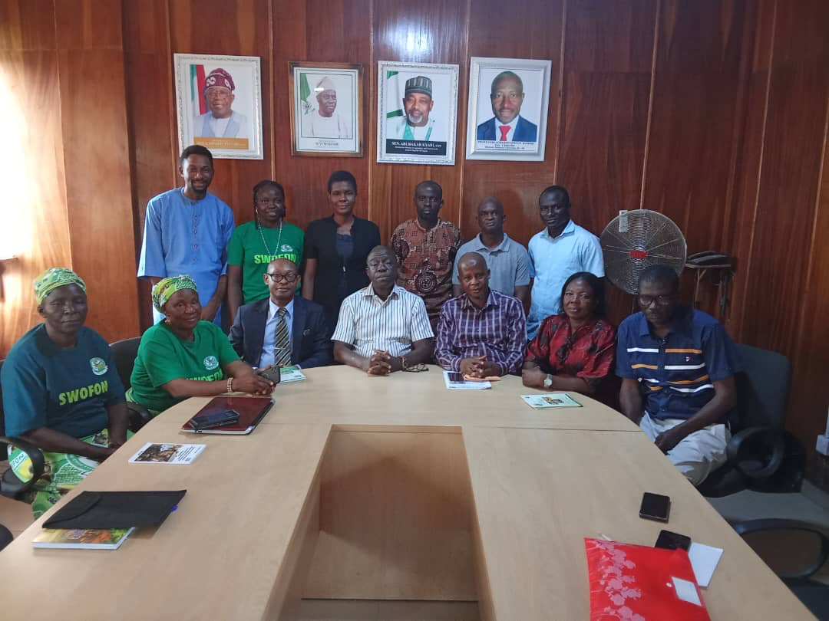

7. VISIT OF CSJ AND SWOFON TO THE NATIONAL HORTICULTURAL RESEARCH INSTITUTE (NIHORT), JERICHO RESERVATION AREA, IBADAN, OYO STATE ON 28TH MAY, 2025.
7.1 OPENING AND ATTENDANCE
The meeting began at exact 10:30am with registration of participants. In attendance were three representatives from SWOFON, Oyo State Chapter, The Coordinator- Akinbade Roseline, Secretary - Oyedeji Oluwatoyin, PRO – Olutunji Oluremi Olufumilayo. Representatives from the Institute were Dr. Adeoye I.B – Head of Department, Farming Systems Extension; Dr. F.B Olajide Taiwo – Director of Research, Dr. M.V David – Director of Administration; A.A Adedimeji – Legal Officer; Oseni Abideen – Extension Researcher; Ojelabi Mercy O. – Program Analyst; Divon H.G – Researcher; Dr. M.O Adewale – Assistant Director of Research; Nnorom Prince – Finance Officer, (CSJ); and Eze Onyekpere – Lead Director CSJ.
7.2 PURPOSE OF MEETING
The Lead Director of CSJ officially opened the meeting by welcoming all participants and outlining the purpose of the engagement. He stated that the visit to NIHORT was part of a broader initiative to link research institutions to farmers for improvement of productivity and value addition along the agriculture value chain. It was also to assess the implementation of agricultural research policies in relation to the federal budget considering the plan, policy, law and budget continuum. Nigeria has an extant Agriculture Policy, a Gender Policy in Agriculture and Federal Extension Service Policy. These policies are to be implemented through resources provided in the budget. He emphasized that the Federal Government of Nigeria oversees no fewer than sixteen agricultural research institutes.
However, he pointed out a concerning disconnect between the innovations of the research institutes and the practice of agriculture at the grassroots level. He highlighted the feedback from members of the Smallholder Women Farmers Organization in Nigeria (SWOFON), who indicated limited awareness and access to agricultural innovations—particularly in the agroecological and extension service sectors. The Lead Director emphasized that CSJ’s presence at NIHORT was aimed at building understanding of the Institute’s ongoing research activities and fostering collaboration between the Institute and the farming community. The ultimate goal, he noted, is to bridge gaps and ensure the research agenda is aligned with farmers' practical needs.
7.3 RESEARCH OVERVIEW AND INNOVATIONS AT NIHORT
Dr. Taiwo Olajide gave an overview of NIHORT's research activities, stating that all research initiatives undertaken by the institute are demand-driven and targeted towards meeting the needs of stakeholders. She emphasized NIHORT’s significant role in providing policy-relevant research guidance and described recent innovations developed by the Institute. He mentioned that NIHORT operates through five regional stations in Mbato-Okigwe, Imo State in South Eastern Nigeria and the other at Bagauda, Kano state. Other substations are in Otukpa – Benue State, Dadinkowa- Gombe State and Ryom - Plateau State.
Recent key innovations include:
- Development of five new tomato varieties.
- Development of tomato seeds that are resistant to Tuta absoluta disease; Absoluta Trap Tray" to trap adult moths, reducing infestation rates and developed bio-pesticide extraction methods using local materials like eucalyptus, neem, and mint leaves, branded as NIHORT-Lyptol and NIHORT Minty.
- Introduction of two new pepper varieties.
- Collection, screening, selection and breeding of improved varieties of important citrus species. Integrated pest and disease management for citrus cultivation; and Citrus storage, processing and general utilization as well as Germplasm Collection.
- Development of Transferable Technology: Rapid Multiplication of Fruit Propagates: banana, plantain, pineapple, mango, indigenous fruit trees.
- Critical interventions in vegetables, spices – improved seeds, disease control, processing, etc.
7.4 STAKEHOLDER ENGAGEMENT AND FARMER-INCLUSIVE PROGRAMS
NIHORT has made remarkable progress in the development and dissemination of farming technologies aimed at improving ease and efficiency in agricultural practices. The institute has also actively contributed to pest management and control.
Dr. Taiwo noted that NIHORT is committed to stakeholder capacity building through regular training programs designed to share vital agricultural information. Additionally, the Institute is compiling a comprehensive database of stakeholders to enhance communication and outreach.
Dr. Adewale elaborated on NIHORT’s stakeholder engagement initiatives, particularly the Research Extension Farmer Input Linkage System (REFILS), which includes workshops that provide a platform for farmers to voice their challenges. He noted that this feedback mechanism is essential for tailoring research to meet real-world agricultural problems.
He also mentioned ongoing collaboration with the Justice and Development Peace Commission (JDPC), aimed at further strengthening the bridge between research institutions and farming communities.

7.5 OPEN DISCUSSION AND POLICY CONCERNS
Eze Onyekpere posed a critical question regarding the apparent reluctance among farmers to adopt new technologies that could enhance their productivity. In response, Dr. Taiwo reiterated that while NIHORT, with support from the Federal Ministry of Agriculture, continues to develop and make available advanced technologies, uptake among farmers remains limited. He suggested that additional efforts are needed to raise awareness and ensure accessibility.
Dr. Adewale added that NIHORT is open to aligning its activities more closely with farmers needs, provided these are effectively communicated through appropriate channels. Eze Onyekpere suggested that NIHORT should consider developing and distributing affordable, small-scale, hand-held farming equipment to encourage adoption. He emphasized on the need to improve access to agricultural research findings and strengthen engagement with policymakers to foster the creation of responsive and effective agricultural policies.
7.6 CONCLUSION
The meeting concluded with a collective agreement on the importance of closing the gap between agricultural research institutes and the end-users of research—namely, the farmers. Participants emphasized the necessity of sustained collaboration, improved communication channels, and stronger integration of farmer feedback into the research and policy-making process.
Eze thanked NIHORT for its openness and innovations and expressed optimism about future partnerships aimed at achieving food security and economic development through inclusive agricultural research and development.
